1．General
MCR200 is an ideal multifunctional reader designed for Banking System. It can encode and read data of stripe in the bank passbook and card. Obtaining read/write parity functions together. According to user requirement the device can integrate with IC card and SAM card module. MCR200 is perfectly choice by bank, stock or etc.

2. Specification
●Voltage: +9V/DC±10% or +5V/DC±10%
●Current ：≤300mA
●Sweep speed：10 ~ 100cm/s
●Head life：500,000 times
●IC card slot life（Main）：200,000 times
●IC card slot life（Sub）：100,000 times
●SAM card slot life：5,000 times
●Encoding standard：According to IBM、ISO、ANSI
●Encoding density：
Track2:75BPI / 210BPI at optional
Track3:210BPI
●Encoding characters:
210BPI Max length: 104
75BPI Max length 37
●Environmental Requirement: Temp. 0℃～45℃,Humidity 10～90％RH
●Dimension（L*W*H,mm）：215*64*65
●Weight：
Equipped IC card module： 700g
Without IC card module ： 650g
●IC card module according to ISO7811/7816 Standard, Chinese financial IC card criterion (PBOC2.0) and EMV Standard

3. Appearance
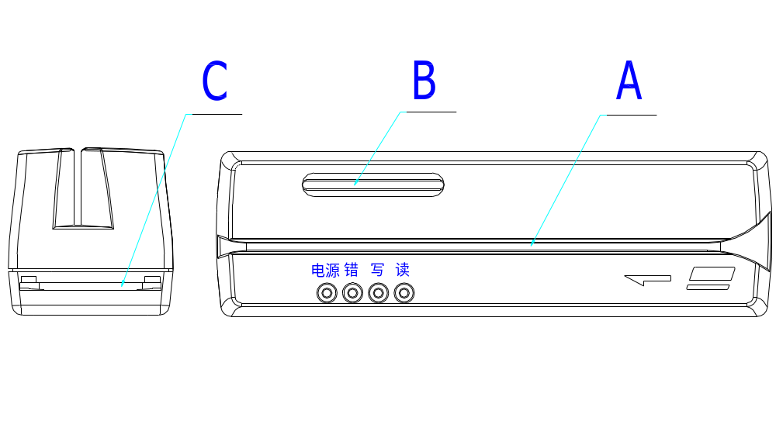
A、MSRE slot B、Main IC card slot C、Sub IC card slot
4. Framework of Working Principle
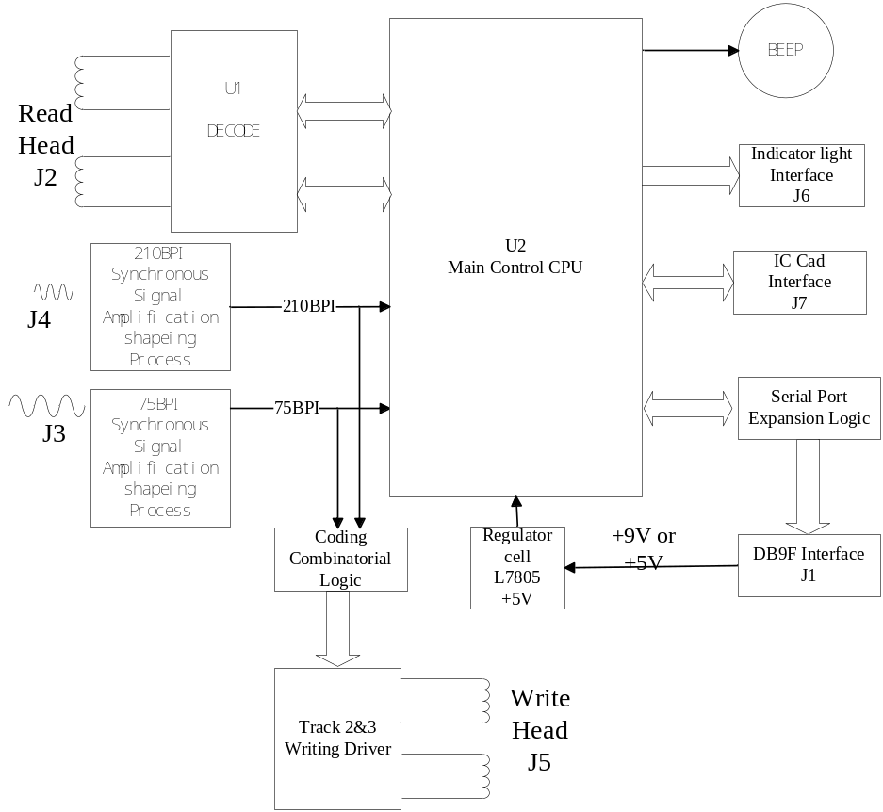

5. Installation
PC(or Terminal) power off, the included cable connect with PC’s(or Terminal) series port, and the DB9F connector link with MCR200. After that power on, the MCR200 will test-self, if all is ok, then can run the MCR200 normally. If the included cable has series port expansion ports(A, K), it can connect with pin pad or other series port device.

6. Interface definition
MCR200 can support 3 series ports. Through the 8 bits DIP switch, the communication parameter (baud rate, data bit) can be set (1 Stopping bit 1).
Signal definition：
Host connector（DB9F）
1 | +5V
2 | TXD
3 | RXD
4 | TXD1
5 | GNG
6 | +9V
7 | RXD2
8 | TXD2
9 | RXD1

7. Command Set

7．1 MSRE Module

7.1.1 Switch setting DIP8
There is a 8bit DIP switch and 1 reset button at the bottom of the MCR200. The DIP switch is used for default parameter, and the reset button is used for Hard Reset.
SW1 | Baud Rate |  | SW2 | Exit when write delay ovetime |  | SW3 | Data Length
ON | 1200 |  | ON | Exit |  | ON | 8Bits no verify
OFF | 9600 |  | OFF | No permission for exit |  | OFF | 7Bit even verify

SW4 | Character Set
ON | ABA1
OFF | ABA2

SW5 | Track2 encoding density set
ON | 75 BPI
OFF | 210BPI

SW6 | Emulation set
ON | BP8902V
OFF | STAR33Ⅲ

SW7 | Encoding Format
ON | Track2 is format3, track3 isformat4
OFF | Track2 and track3 is format4

SW8 | A/B port Set when power on
ON | A port
OFF | B port

7.1.2 The Character set for reading and writing
MCR200 can select character set I or character set II, the default setting is set by SW2 switch.

Character setⅠ
ASCII | 0 | 1 | 2 | 3 | 4 | 5 | 6 | 7 | 8 | 9 | : | # | @ | ’ | = | ？
Hex | 30 | 31 | 32 | 33 | 34 | 35 | 36 | 37 | 38 | 39 | 3A | 23 | 40 | 27 | 3D | 3F
ABA | 0 | 1 | 2 | 3 | 4 | 5 | 6 | 7 | 8 | 9 | A | B | C | D | E | F
Note: For the characters listed in table, if >1FH, then will be as 30H; <20H,then will be neglected.

Character set Ⅱ
ASCII | 0 | 1 | 2 | 3 | 4 | 5 | 6 | 7 | 8 | 9 | : | # | @ | ’ | = | ？
Hex | 30 | 31 | 32 | 33 | 34 | 35 | 36 | 37 | 38 | 39 | 3A | 23 | 40 | 27 | 3D | 3F
ABA | 0 | 1 | 2 | 3 | 4 | 5 | 6 | 7 | 8 | 9 | A | B | C | D | D | F
Note: 1.For the characters listed in table, if >1FH, then will be as 30H; <20H,then will be neglected.
2. When = or ’(ASCII) is written in the magnetic card, it will be changed into D (ABA). When this data is read, D (ABA) will be changed into = (ASCII).

7.1.3 The data record format standard
Standard Sequence | Initiative Character | Stop Character | Remark
Standard 1 | BA | F | IBMF
Standard 2 | BA | F | IBMF
Standard 3 | BA | C | IBMC
Standard 4 | B | F | ISO
Standard 5 | D | F | DIN
Standard 6 | B | C | SPECIAL

7.1.4 Common Control Command
7,1.4.1 Reset and Handshake command
Command | Function | Returning Code
ESC 0 (1b 30) | Soft Reset command, quit read/write status | No
ESC S (1b 53) | Reset command, reset the MCR200 | No
ESC e (1b 65) | Handshake command | ESC y (1b 79)

7.1.4.2 Select port command
Command | Function
ESC % B (1b 25 42) | Select host port, close extend port
ESC % A (1b 25 41) | Select extend port A, close host port
ESC % D (1b 25 44) | Select extend port D, close host port
ESC % K (1b 25 4B) | Select extend port K, close host port
ESC % I (1b 25 49) | Select IC card interface, close host port , and the green LED will be lit
ESC % J (1b 25 4A) | Close IC card interface, select host port, and green LED will be closed
Note: If the extend port is selected, all control commands can not work except select port command.

7.1.4.3 Initiative encoding position setting
Command | Initiative encoding position
ESC 6 （1B 36） | *12mm
ESC 7 （1B 37） | 20mm
ESC 8 （1B 38） | 22mm
ESC 9 （1B 39） | 25mm
Noted: The default position is 12mm

7.1.4.4 Encoding density setting
Command | Function
ESC L(1b 4c) | Set second track as 75BPI
ESC H(1b 48) | Set second track as 210BPI
Note: The default setting of the second track is defined by DIP switch

7.1.4.5 Record Standard Command
Track | Command | Standard Sequence
 | ESC 1 （1B 31） | Standard 1
 | ESC 2 （1B 32） | Standard 2
Second | ESC 3 （1B 33） | Standard 3
 | ESC 4 （1B 34） | Standard 4
 | ESC 5 （1B 35） | Standard 5
 | ESC Z （1B 5A） | Standard 6
 | ESC T1（1B 54 31） | Standard 1
 | ESC T2（1B 54 32） | Standard 2
Third | ESC T3（1B 54 33） | Standard 3
 | ESC T4（1B 54 34） | Standard 4
 | ESC T5（1B 54 35） | Standard 5
 | ESC TZ（1B 54 5A） | Standard 6
 | ESC B1（1B 42 31） | Standard 1
 | ESC B2（1B 42 32） | Standard 2
Double | ESC B3（1B 42 33） | Standard 3
 | ESC B4（1B 42 34） | Standard 4
 | ESC B5（1B 42 35） | Standard 5
 | ESC BZ（1B 42 5A） | Standard 6

7.1.5 The first control command set
Note: MCR200 can identify two control command sets. The user can select one of them.

(1)Read Command
Command | Function | Return Data
ESC ] (1b 5d) | Read the second track | ESC s TK2data ？ FS  1B 73 TK2data 3F 1C
ESC T ]  (1b 54 5d) | Read the third track | ESC s A TK3data ？ FS  1B 73 41 TK3data 3F 1C
ESC B ]  (1b 42 5d) | Read double tracks | ESC s TK2data A TK3data ？ FS  1B 73 TK2data 41 TK3data 3F 1C
Note:TK2data means the second track data has been read, and TK 3data means the third track data has been read. If the data reading failed, it will show the data as DEL (7f).

(2)Write Command
Command | Function
ESC t TK2data GS ESC \  1b 74 TK2data 1d 1b 5c | Write the second track
ESC t A TK3data GS ESC \  1b 74 41 TK2data 1d 1b 5c | Write the third track
ESC t TK2data A TK3data GS ESC \  1b 74 TK2data 41 TK2data 1d 1b 5c | Write double tracks
Note: TK2data means the data is waiting for writing in the second track, and TK 3data means the data is waiting for writing in the third track.

(3)Command for returning the state
ESC j (1b 6a)
This command can return the state of the finish of reading/writing
Function | Return state code
The second track | ESC r p / q / r (1b 72 70/71/72)
The third track | ESC T r p / q / r (1b 54 72 70/71/72)
Double tracks | ESC B r p / q / r (1b 42 72 70/71/72)
Note: The last bit in the returning state code is ‘P’that means success; ‘q’ means fail; ‘r’ means not reading/writing operation.

7.1.7 The Second control command set
(1)Read Command
Command | Function | Return Data
ESC r  (1b 72) | Read the second track | ESC s TK2data ？ FS ESC state character  1b 73 TK2data 3f 1c 1b state character
ESC p  (1b 70) | Read the third track | ESC t TK3data ？ FS ESC state character  1b 74 TK3data 3f 1c 1b state character
ESC q  (1b 71) | Read double tracks | ESC s TK2data ? ESC t TK3data ？ FS ESC state character  1b 73 TK2data 3f 1b 74 TK3data 3f 1c 1b state character
Note：TK2data means the second track data has been read, and TK 3data means the third track data has been read. If the data reading failed, it will show the data as DEL (7f).

State character: 30H means reading success
31H means the second track reading failed
32H means the third track reading failed
33H means double tracks reading failed
(2)Write Command
Command | Function | Return Code
ESC w ESC s TK2data ? FS  1b 77 1b 73 TK2data 3f 1c | Write the second track | ESC state character
ESC u ESC t TK3data ? FS  1b 75 1b 74 TK2data 3f 1c | Write the third track | ESC state character
ESC v ESC s TK2data ? ESC t TK3data ? FS  1b 76 1b 73 TK2data 3f 1b 74 TK2data 3f 1c | Write double tracks | ESC state character
Note:TK2data means the data is waiting for writing in the second track, and TK 3data means the data is waiting for writing in the third track.

State character: 30H means writing success
31H means the second track writing failed
32H means the third track writing failed
33H means double tracks writing failed
34H means the write command or data format is illegal

7.2 IC card module
7.2.1 Communication protocol
There are two protocols to transfer:：

(1) TLP224（Intersected character）protocol
The format when transfer of information is right:
<ACK> <LN> <MESSAGE> <LRC>
ACK: 60H，State right command or status
LN： State the length of info ( Command or status code)
MESSAGE： Command or status code
LRC: The longitudinal redundant character . The value of XOR with <ACK>, <LN>, <MESSAGE>.

The format when transfer of information is wrong:
< NACK > <LN> <LRC>
NACK: E0H，State error command or status
LN： 00H
LRC： E0H

Sound code file excute the following process:
The transferring byte will be divided up two ASCII codes, for example, transfer the “3AH”, the sound code file will send 33 and 41H, so that can avoid collision with the system controlling characters. And append the stopping character (EOT) at the end. EOT＝03H

(2)BLOCK PROTOCOL
Format
NAD | PCB | LEN | DAT | EDC
NAD：Initiative and objective identifier
Identifier
7 | 6 | 5 | 4 | 3 | 2 | 1 | 0
High half byte state objective identifier, low half byte state initiative identifier.
Host＝2；IC card reader/writer＝4；
PCB：State the type of block, the format will be decide by the type, describe as following:
Type1：I – Blocks（Information Blocks）Support the data exchange between initiative and objective.
Format：
Bit 7 6 5 4 3 2 1 0
0 | S | 0 | 0 | 0 | 0 | 0 | 0

Sequence bit
Rest will not use
The six bit is sequence, it will be set “0” when power on, the sequence bit will be 0 when the initiative send the first I – Block, after that the sequence bit will be add 1 when transferring next I – Block.
The sequence bit will be the same as the initiative.

Type2：R – Blocks（Receive Ready Blocks）
Format：
Bit 7 6 5 4 3 2 1 0
1 | 0 | 0 | S | 0 | 0 | `E | V
1 = XOR EDC Error
1 = Other error
1 = Sequence

Type3：S – Blocks（Supervisory Blocks）
S – Blocks Ask for the objective to set the sequence as 0, and return to state transfer over.
Bit 7 6 5 4 3 2 1 0 Synchronization require
1 | 1 | 0 | 0 | 0 | 0 | 0 | 0
Bit 7 6 5 4 3 2 1 0 Synchronization responses
1 | 1 | 1 | 0 | 0 | 0 | 0 | 0

LEN：the length of the info.
DAT：the transferring info(command block or returning status)
EDC：The longitudinal redundant character . The value of XOR with <ACK>, <LN>, <MESSAGE>.

For example：Pick up 4 stochastic data from main IC card:
TLP224 Format：
Power on，command：12H
The head of command: 60H 01H 12H 73H
The format of intersect transferring data：36H 30H 30H 31H 31H 32H 37H 33H 03H
To pick up 4 stochastic data：00H 84H 00H 00H 04H
The head of command: 60H 06H 13H 00H 84H 00H 00H 04H F5H
The format of intersect transferring data：36H 30H 30H 36H 31H 33H 30H 30H 38H 34H 30H 30H 30H 30H 30H 34H 46H 35H 03H
BLOCK PROTOCOL Format：
Transfer data：
Power on，command：12H
Format：42H 00H 01H 12H 51H
To pick up 4 stochastic data：00H 84H 00H 00H 04H
Format：42H 40H 06H 13H 00H 84H 00H 00H 04H 97H

7.2.2 Command
Note：
1、Default setting: Baud rate 9600，8Bit no parity，1 Starting bit, 1 stopping bit
2、Only Select IC card Interface（ESC%I）, the following command can be available.

7.2.2.1 Power Off
Command： 11H have the main IC card module power off
19H have the selected sub card module or SAM module power off

7.2.2.2 Power On
Command： 12H have the main IC card module power on
1AH have the selected sub card module or SAM module power on

7.2.2.3 ISO Output
Command： 13H Pick up data from main IC card
1BH Pick up data from selected sub card module or SAM module

7.2.2.4 ISO Input
Command： 14H Send the data to main IC card
1CH Send the data to selected sub card module or SAM module

7.2.2.5 APDU Data Envelopment Exchange
Command： 15H Send APDU data to main IC card, and obtain the response
1DH Send APDU data to selected sub card module or SAM module, and obtain the response

7.2.2.6 Select and define the type of main IC card

Command：17H T 00H
Description for the parameter “T”：
Hex | Type of main IC card
02H | CPU card
08H | SLE4418/4428（GPM8K）
09H | SLE4432/4442（GPM2K or PCB2032/2042）

7.2.2.7 Select and define the type of sub IC card(or SAM card)
Command：1FH T N
Description for the parameter “T”：
Hex | Type of main IC card
02H | CPU card
08H | SLE4418/4428（GPM8K）
09H | SLE4432/4442（GPM2K or PCB2032/2042）

Description for the parameter “N”：
N(Hex） | Card for operation
01H | Sub card
02H | SAM card 1
03H | SAM card 2
04H | SAM card 3

7.2.2.8 SLE4432/4442 Command
Read data area：
（ISO OUT）00H B0H 00H（Address）（Read Length）
Write data area：
（ISO IN） 00H D0H 00H（Address）（Write Length）（Data0..Data n）
Read protecting area：
（ISO OUT）00H B0H 80H 00H 04H
Write protecting area：
（ISO IN） 00H D0H 80H（Address）（Write Length）（Data0..Data n）
Read cryptogram area
（ISO OUT）00H B0H C0H 00H 04H
Write cryptogram area：
（ISO IN） 00H D0H C0H（Address）（Write Length）（Data0..Data n）
Compare cryptogram：
（ISO IN） 00H 20H 00H 00H 03H（Code3,Code2,Code1）

7.2.2.9 SLE4418/4428 Command
Read data area：
（ISO OUT）00H B0H（AddressH）（AddressL）（Read Length）
Write data area：
（ISO IN） 00H D0H（AddressH）（AddressL）（Write Length）（Data0..Data n）
Read protecting area：
（ISO OUT）00H B0H（80H＋AddressH）00H 20H
Write protecting area：
（ISO IN） 00H D0H（80H＋AddressH）（AddressL）01H（Data）
Read cryptogram area
（ISO OUT）00H B0H C0H 00H 03H
Write cryptogram area：
（ISO IN） 00H D0H C0H（Address）（Write Length）（Data0..Data n）
Compare cryptogram：
（ISO IN） 00H 20H 00H 00H 02H（Code2,Code1）

7.2.2.10 Returning status value
Hex | Description
00H | Successfully execute for R/W operation
01H | Unknown driving or command
03H | The length of parameter is error
05H | Returning info overflow
09H | Communication protocol error
10H | Card resetting response erro
15H | Card power off
A2H | Halt connect for overtime
EEH | The module is busy
F8H | Card short circuit
FBH | Not insert card

7.2.2.11 Set Operating Mode
This command selects the operating mode of treatment of an asynchronous card.
The following two modes exist:
• Generic ISO mode
• EMV-compliant mode
Some commands are not allowed in EMV mode, while others undergo changes in their
behavior.
Format
17h 00h Mode Main slot
1Fh 00h Mode Auxiliary slot
Where:
Mode: Represents the operating mode to be selected
47h selects the generic ISO mode
45h selects the EMV-compliant mode
00h returns the currently selected mode
Response
S Mode
Where:
Mode: Represents the currently selected mode
47h = generic ISO mode
45h = EMV-compliant mode

8. Maintenance
8．1 Daily maintenance
Clean Magnetic Head | Use special cleaning card that is soaked by industrial alcohol to clean head for 5-10 times.
Clean encoder | Use special cleaning card that is soaked by industrial alcohol to clean the gear of encoder for 5-10 times.

8．2 Common problem and solution
Common Problem | Solution
1. W/R error | Clean the head and encoder
2. No response when R/W MSRE or IC module | Check the cable connect and the setting for COMM.

